- Create a new GitHub repository.
- Created new repository named as “flask-project” in GitHub, SS mention below.
- 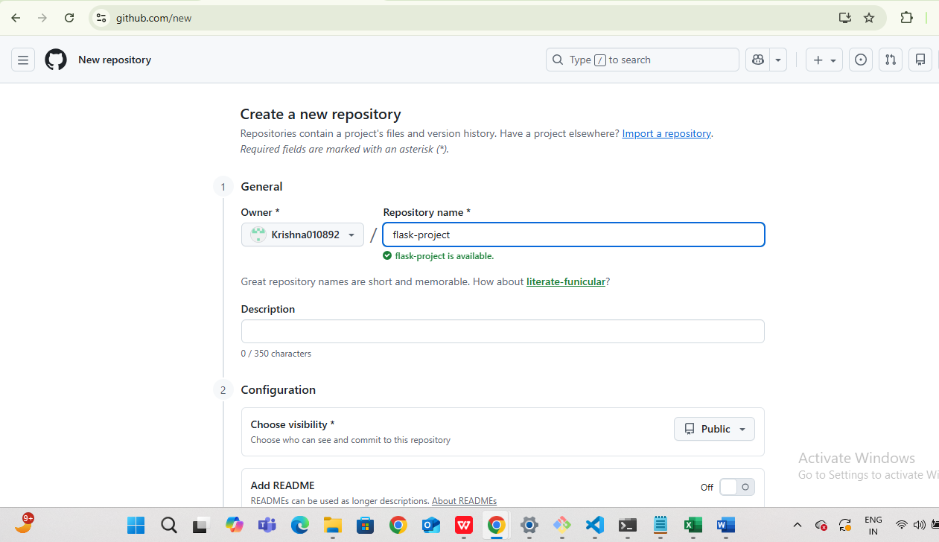
- Clone the repository to your local machine using SSH (generate an SSH key if needed, add the public key to your GitHub account).
- Created a clone of repository to my local machine using SSH, mention below.
- “git clone git@github.com:Krishna010892/flask-project.git” also SS mention below.
- Create a new branch named after your username (e.g., Tutedude).
- Created a new branch “git branch krishna”, SS mention below.
- Add your Flask project files to this branch.
- Flask project file added to branch “krishna010892”, SS mention below
- 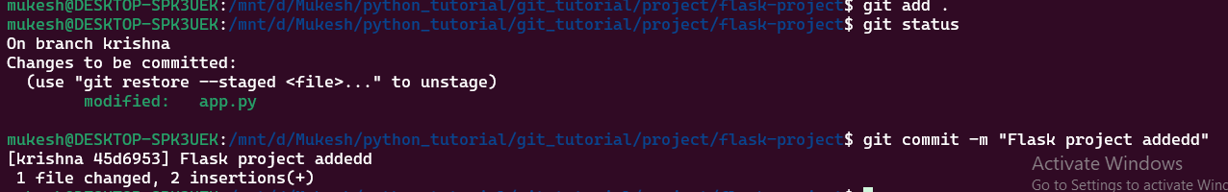

- Commit the changes and merge the branch into the main branch.
- Commit the changes successfully.
- 
- New branch merge to main branch
- 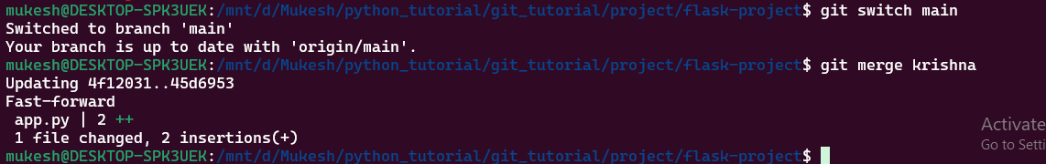

- Create a new branch named <your_name>_new (e.g., Tutedude_new).
- New branch created as “krishna_new” command “git branch krishna_new”, SS mention below.
- 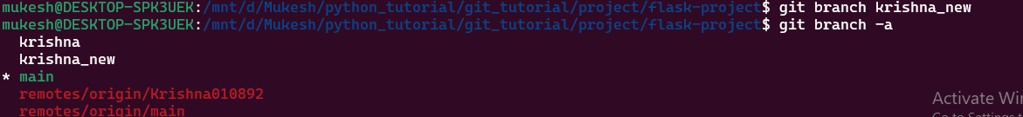
- Update the content of the JSON file used for the /api route in this branch.
- Json updated used /api route in this branch.
- 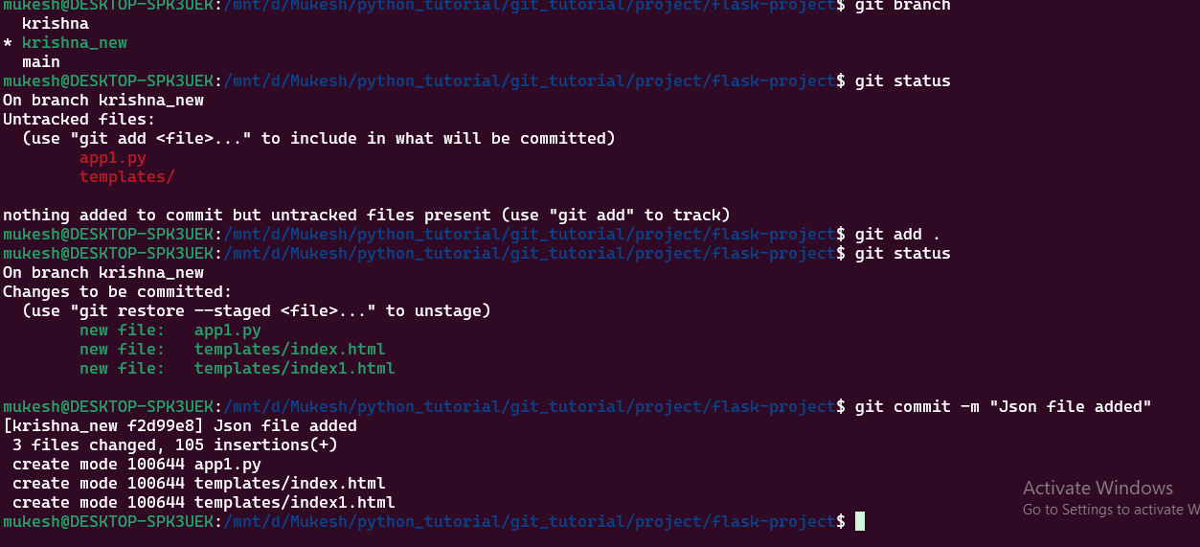

- Merge the <your_name>_new branch into the main branch.
- Branch merged with main “git merge krishna_new”, SS mention below.
- 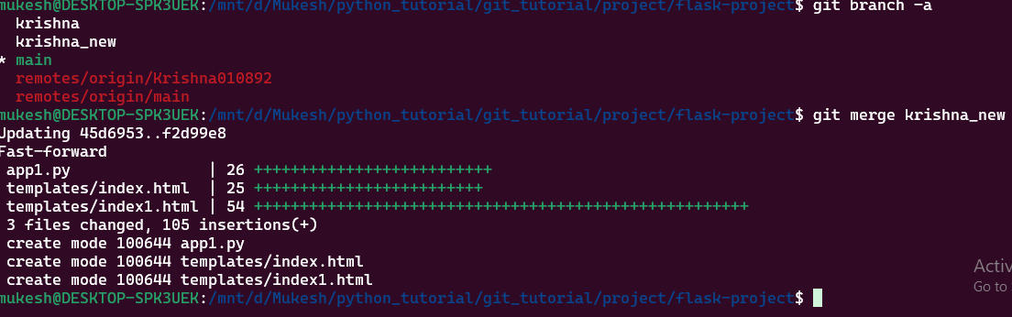
- If there are conflicts during the merge, resolve them by accepting the changes from the <your_name>_new branch.
- All fine, merged properly.
- Add the resolved changes to the staging area, commit them, and push the updates to the remote repository.
- Commit the file and pushed to the remote repository.
- 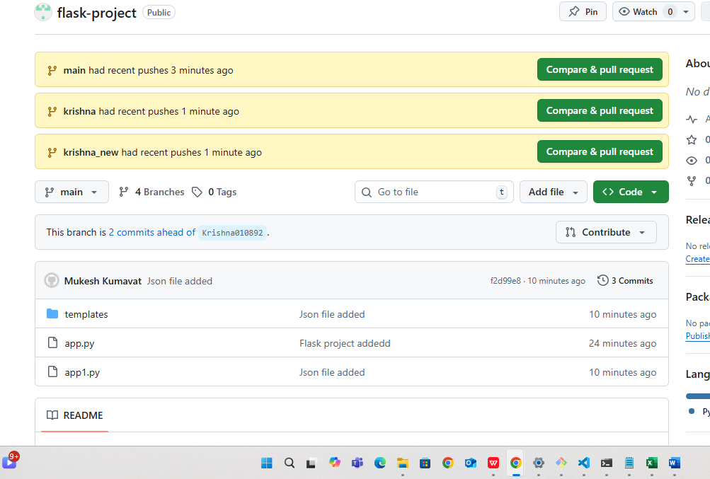

3. Branch Creation:
- Create two branches: master_1 and master_2 from the main branch.
- Two branches were created as “master_1 and master_2”, SS mention below.
- 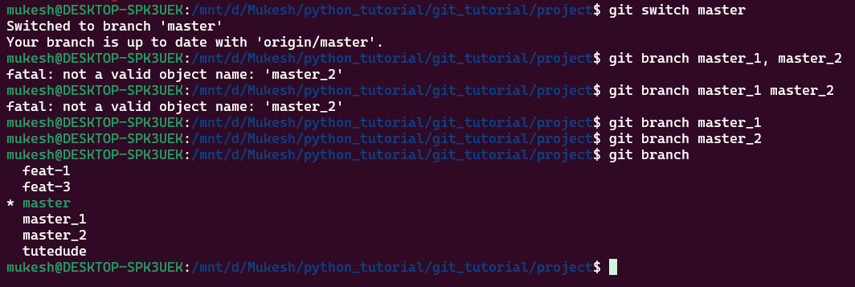
- Feature Development in master_1:
- In the master_1 branch, create a To-Do Page in the frontend.
- In master_1 branch created a file name “todo.html” for frontend.
- 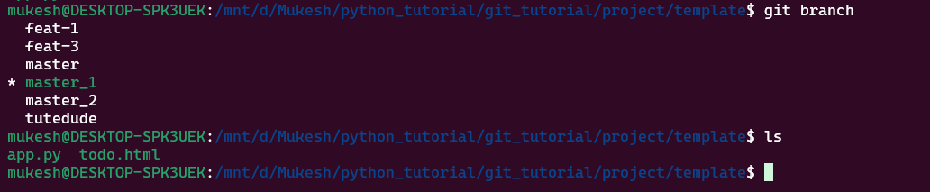
  - The page should contain a form with the following fields:
    - Item Name
    - Item Description
- File “todo.html” code mention below with fields Item Name and Item Description.
- <!DOCTYPE html>
- <html>
- <head>
- <title>To-Do Page</title>
- </head>
- <body>
- <h2>Add To-Do Item</h2>

- <form method="post" action="/submittodoitem">
- <label>Item Name:</label><br>
- <input type="text" name="itemName" required><br><br>

- <label>Item Description:</label><br>
- <textarea name="itemDescription" required></textarea><br><br>

- <button type="submit">Submit</button>
- </form>
- </body>
- </html>

- Backend API in master_2:
- In the master_2 branch, create a backend route named /submittodoitem.
- Created backed route named /submittodoitem in master_2, code mention below and SS mention below.
- from flask import Flask, request, jsonify
- from pymongo import MongoClient

- app = Flask(__name__)

- client = MongoClient("mongodb://localhost:27017/")
- db = client.todo_db
- collection = db.items

- @app.route("/submittodoitem", methods=["POST"])
- def submit_todo_item():
- item_name = request.form.get("itemName")
- item_description = request.form.get("itemDescription")

- collection.insert_one({
- "itemName": item_name,
- "itemDescription": item_description
- })

- return jsonify({"message": "To-Do item stored successfully"})

- 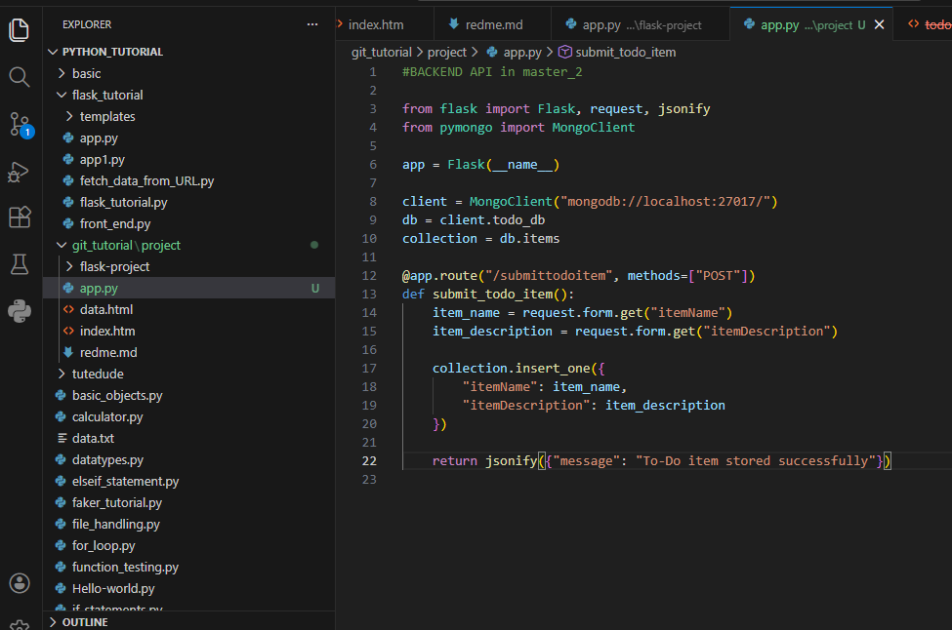
- This route will:
  - Accept itemName and itemDescription via a POST request.
  - Store these details in a MongoDB database.
- Code mention below
- client = MongoClient("mongodb://localhost:27017/")
- db = client.todo_db
- collection = db.items

- @app.route("/submittodoitem", methods=["POST"])
- def submit_todo_item():
- item_name = request.form.get("itemName")
- item_description = request.form.get("itemDescription")

- collection.insert_one({
- "itemName": item_name,
- "itemDescription": item_description
- })

- return jsonify({"message": "To-Do item stored successfully"})

- Merging Changes:
- Merge the changes from both master_1 and master_2 into the main branch.
- master_1 and master_2 has been merged to main branc.
- Command – “git merge master_1” and “git merge master_2”
- 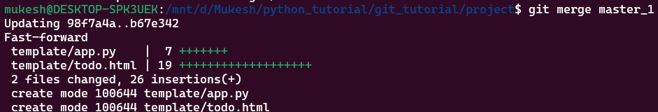
- 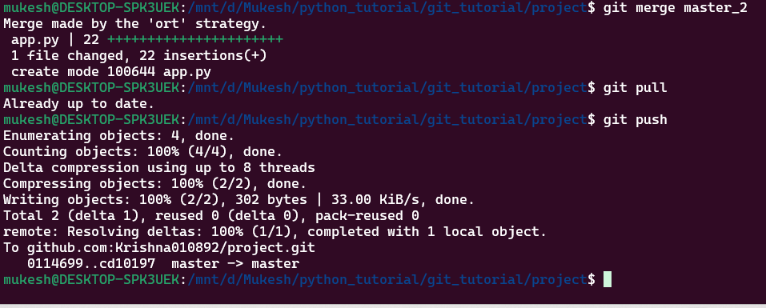

4. Enhancing the To-Do Form in master_1:
- In the master_1 branch, add the following fields to the To-Do form:
  - Item ID
  - Item UUID
  - Item Hash
- Above all 3 fields added in todo.html file, code mention below.
- <label>Item ID:</label><br>
- <input type="text" name="itemId"><br><br>

- <label>Item UUID:</label><br>
- <input type="text" name="itemUUID"><br><br>

- <label>Item Hash:</label><br>
- <input type="text" name="itemHash"><br><br>

- Committing in Sequence:
- Add and commit each field separately in the following order:
  - First commit: Add Item ID field.
  - Second commit: Add Item UUID field.
  - Third commit: Add Item Hash field.
- Successfully Add and commit each field separately in the following order, SS mention below.
- 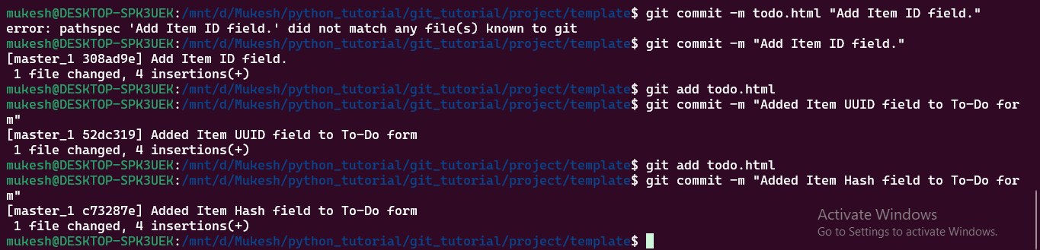
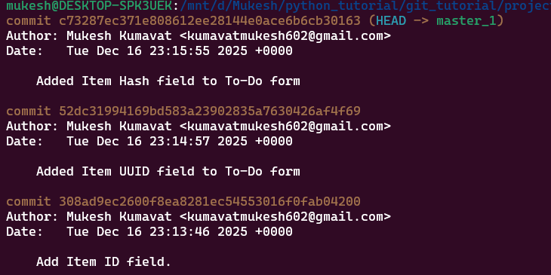

- Merging to main:
- Merge the master_1 branch into the main branch.
- Master_1 branch has been merged successfully to main branch, SS and command mention below.
- “git merge master_1”
- 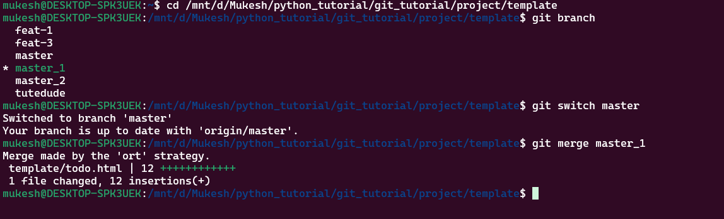
- Git Reset and Commit Deletion:
- In the main branch, use Git Reset to roll back to the commit where only the Item ID field was added.
- Command for view only the item ID field was added “git log --oneline”
- Use git reset --soft to ensure changes remain staged.
- Command used “git reset –soft 308ad9e” to ensure the changes remain staged
- Re-commit this state to the main branch.
- Command use for re-commit “git commit -m "Reset main to Item ID only state"”
- Merge this updated state to the main branch.
- Forced push required because history changed.
- Command “git push --force origin master”
- 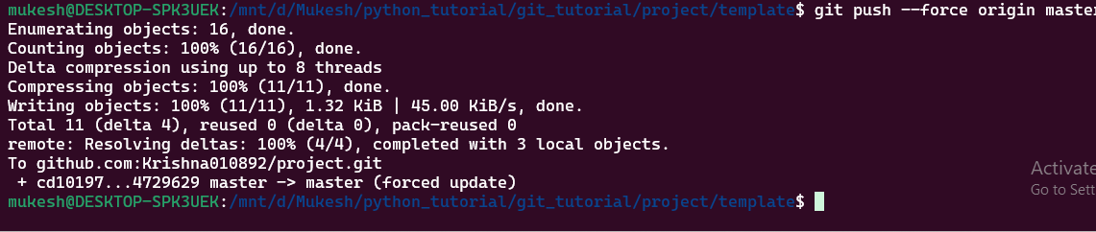
- Rebasing Changes:
- Rebase the updated changes in the main branch to the master_1 branch.
- Clarification:
  - During rebasing, preserve individual commits to maintain the commit history for each change (i.e., do not squash commits).
  - Use git rebase main master_1 to integrate changes from the main branch back into the master_1 branch.
- 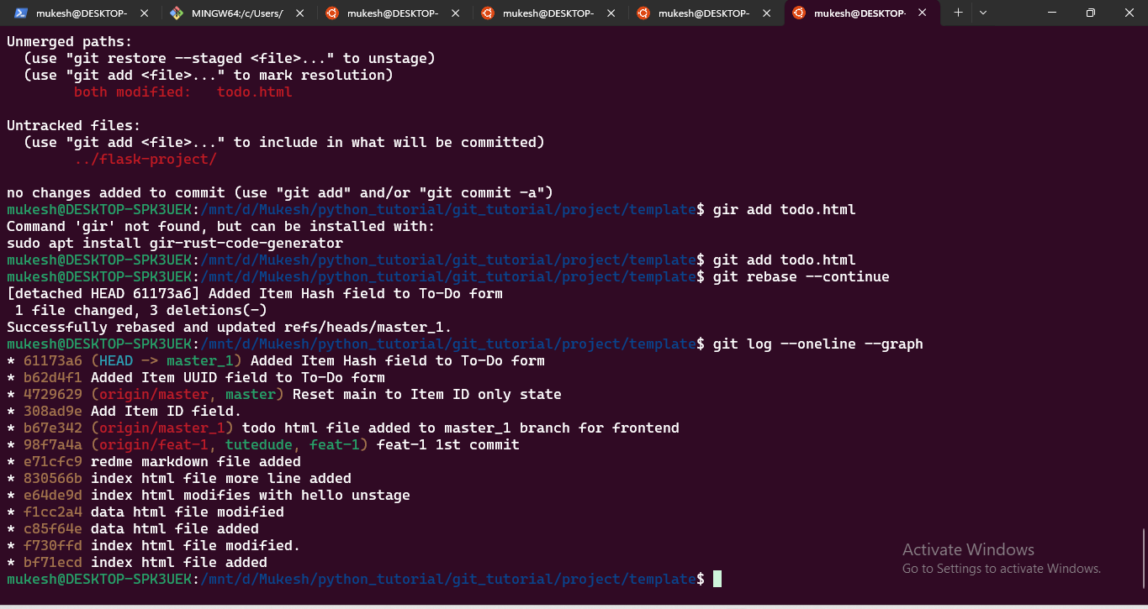
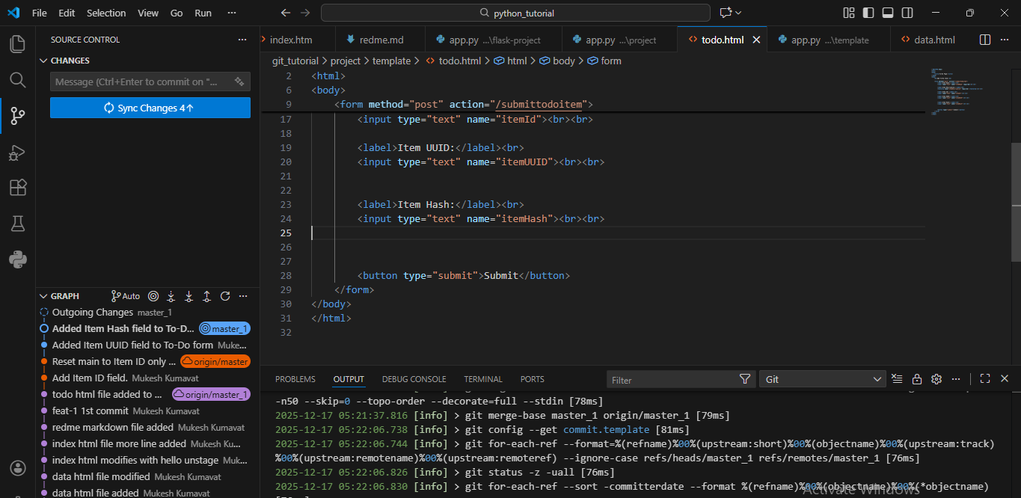
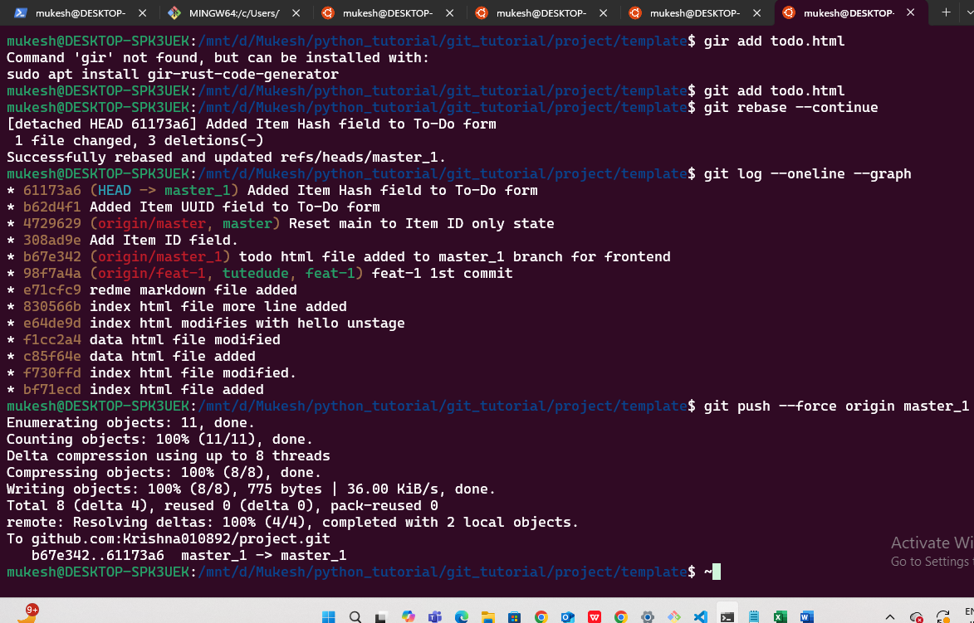

Submission Guidelines -: Attach Screenshots or command along with explanation and submit in doc(google doc or microsoft doc) format , also share link of your github repo

